**Project Report – QuizWiz**



Session: 2021 – 2025

**Submitted by:**

Muhammad Abdullah 2021-CS-82

**Supervised by:**

Mr. Laeeq Khan Niazi

**Department of Computer Science**

**University of Engineering and Technology**

**Lahore Pakistan**

Table of Contents

Chapter 1: Introduction 2

1.1 Overview 2

1.2 Features 2

1.2.1 User Registration and Authorization 2

1.2.2 User Roles 2

1.2.3 Class Management 2

1.2.4 Quiz Bank Management 3

1.2.5 Quiz Sharing 3

1.2.6 Test Management 3

1.2.7 Test Attempting 3

1.2.8 Evaluate Test 3

1.2.9 Release Result 3

1.2.10 Reporting 3

1.2.11 Remarks and Feedback 3

1.3 Similar Apps Overview and Comparison 4

1.3.1 Kahoot 4

Chapter 2: Diagrams 6

2.1 Use-Case Diagram 6

2.2 Sequence Diagram 7

2.3 Class Diagram 8

2.4 DFD level 0 Diagram 9

Chapter 3: 9

3.1 Version Control: GitHub 9

3.2 Communication Tool: Slack 12

3.3 Project Management Tool: ClickUp 13

3.4 Best Practices 15

Chapter 4: 17

4.1 SignUp 17

4.2 SignIn 18

4.3 Add Question/MCQ 19

4.4 Update Quiz 20

4.5 Give Quiz 21

# Chapter 1: Introduction

## 1.1 Overview

Welcome to QuizWiz, your go-to platform for revolutionizing the way quizzes and assessments are conducted in educational settings. QuizWiz is a feature-rich application designed to simplify the quiz creation process for educators, empower students to engage in interactive assessments and foster collaboration among teachers. This documentation aims to provide you with a comprehensive understanding of QuizWiz's extensive features and functionalities.

## 1.2 Features

QuizWiz boasts a range of features tailored to meet the diverse needs of educators and students alike. Here's a brief overview of the key functionalities offered:

## 1.2.1 User Registration and Authorization

* Login and Sign Up: QuizWiz facilitates an effortless user registration process, allowing individuals to create unique usernames with secure password protection, ensuring a seamless and secure entry into the platform

## 1.2.2 User Roles

* Teacher and Student Roles: Employing intuitive role-based access control, QuizWiz defines and enforces role-specific functionalities, ensuring that each user experiences the platform based on their designated role.

## 1.2.3 Class Management

* Class Creation: Teachers are empowered to easily create and manage classes within QuizWiz, providing a centralized hub for organizing educational activities.
* Student Enrollment: Teachers have the flexibility to add or remove students from classes, while students can accept invitations or leave classes, streamlining the process of managing class rosters.

## 1.2.4 Quiz Bank Management

* Quiz Bank Tools: Teachers are equipped with dedicated tools to efficiently manage quiz banks, offering a centralized repository for storing and organizing quiz questions.
* Add, Edit, and Delete: Teachers can seamlessly add, edit, and delete quiz questions within the quiz banks, ensuring the adaptability of assessment content.

## 1.2.5 Quiz Sharing

* Access Requests: Teachers can request access to quiz banks from their peers, promoting collaboration and resource sharing within the educational community.
* Sharing Functionality: Teachers can share view access to their quiz banks with colleagues, fostering a collaborative approach to quiz creation and management.

## 1.2.6 Test Management

* Test Creation: Teachers can effortlessly create tests by selecting questions from the quiz banks, providing a streamlined process for designing assessments.
* Randomized Tests: QuizWiz offers the option for teachers to create tests with randomized questions, enhancing the diversity and fairness of assessments.
* Automatic Repeating Tests: Teachers can schedule and create repeating tests, automating the process of recurring assessments.

## 1.2.7 Test Attempting

* Student Test-Taking: Students have the opportunity to take tests based on class enrollment and scheduled time, ensuring a synchronized and organized testing experience.
* Marking and Skipping: Students can mark or skip questions during a test, allowing for a personalized and adaptive testing approach.
* Submission: Students can easily submit completed tests, streamlining the assessment process and providing timely feedback.

## 1.2.8 Evaluate Test

* Automated Evaluation: QuizWiz incorporates an automated test evaluation system, reducing the manual workload for teachers and ensuring consistency in grading.
* Real-Time Results: Teachers can view test results in real-time, allowing for immediate insights into student performance.

## 1.2.9 Release Result

* Result Release: QuizWiz offers functionality for both manual and scheduled release of test results, providing flexibility and control over the dissemination of assessment outcomes.

## 1.2.10 Reporting

* Analytics Tools: Teachers have access to robust reporting tools for analyzing overall class and individual student performance, enabling data-driven insights for instructional improvement.
* Student Access: Students can access their performance reviews, fostering self-awareness and accountability.

## 1.2.11 Remarks and Feedback

* Feedback System: Students can provide feedback on assessments, fostering a culture of communication and continuous improvement.
* Teacher Remarks: Teachers can provide remarks about student performance, offering personalized insights and constructive feedback.

## 1.3 Similar Apps Overview and Comparison

To provide context for QuizWiz, let's briefly explore two similar quiz applications in the educational technology landscape.

## 1.3.1 Kahoot

**Overview:**

Kahoot is a widely popular game-based learning platform that brings an element of gamification to the educational experience. Designed for interactive quizzes, surveys, and discussions, Kahoot engages students through a competitive and entertaining format. It is accessible across various devices, making it a versatile tool for both in-person and remote learning environments.

**Key Features:**

**Game-Based Learning:**

Kahoot leverages game dynamics to make learning fun and engaging.

Users participate in quizzes presented in a game-show format, fostering excitement and competition.

**Multi-Device Accessibility:**

Students can use smartphones, tablets, or computers to participate, promoting flexibility and accessibility.

**Ready-Made Quizzes:**

Kahoot offers a vast library of pre-existing quizzes on diverse topics, saving educators time on content creation.

**Live and Self-Paced Modes:**

Supports live sessions for real-time interaction.

Students can also complete challenges at their own pace, accommodating various learning styles.

**Collaborative Learning:**

Allows for team-based competitions, promoting collaboration and peer-to-peer learning.

**Analytics and Reporting:**

Provides post-session analytics for educators to assess student performance.

Data-driven insights aid in identifying areas for improvement and understanding student engagement.

**Comparison with QuizWiz:**

**Game-Based vs. Comprehensive Assessment:**

While Kahoot primarily focuses on game-based learning and quick quizzes, QuizWiz offers a broader range of assessment tools, including in-depth test creation and evaluation features.

**Role-Based Access Control:**

QuizWiz emphasizes role-based access control, providing distinct functionalities for teachers and students, ensuring a tailored experience for each user.

**Class and Quiz Bank Management:**

QuizWiz places a strong emphasis on class and quiz bank management, allowing teachers to organize content systematically, and fostering a more structured educational environment.

**Scheduled Repeating Tests:**

QuizWiz introduces the feature of automated, scheduled repeating tests, providing educators with a tool for regular and systematic assessment.

**Real-Time Results and Reporting:**

While both platforms offer analytics, QuizWiz's real-time results feature allows educators to gain immediate insights into student performance during a test, offering a more dynamic assessment experience.

**Feedback and Remarks:**

QuizWiz incorporates a comprehensive feedback system, allowing students to provide feedback and teachers to provide remarks, fostering a robust communication channel for continuous improvement

**Diverse Question Types:**

QuizWiz supports various question types, ensuring a versatile assessment experience, whereas Kahoot primarily focuses on multiple-choice questions.

In summary, while Kahoot excels in gamified, quick quizzes, QuizWiz positions itself as a comprehensive assessment platform with a broader range of features catering to the diverse needs of educators and students in both game-based and traditional assessment settings.

# Chapter 2: Diagrams

## 2.1 Use-Case Diagram

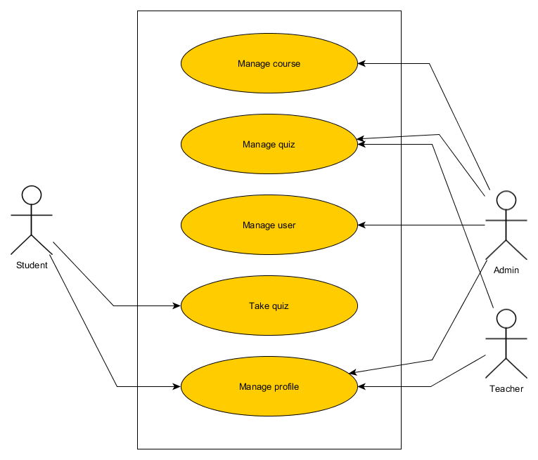

## 2.2 Sequence Diagram

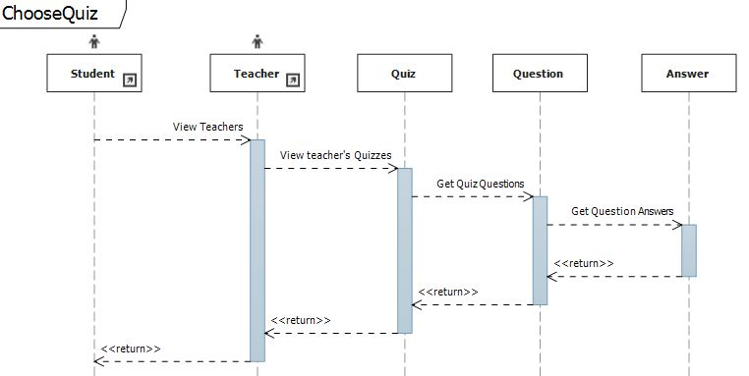

## 2.3 Class Diagram

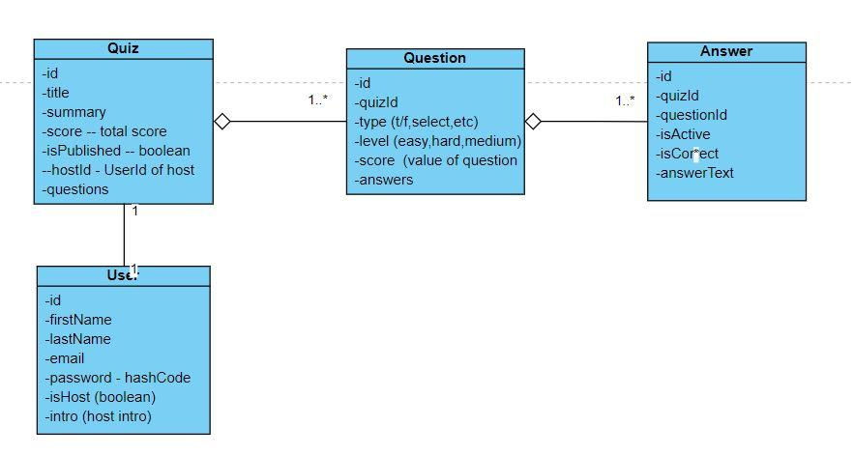

## 2.4 DFD level 0 Diagram

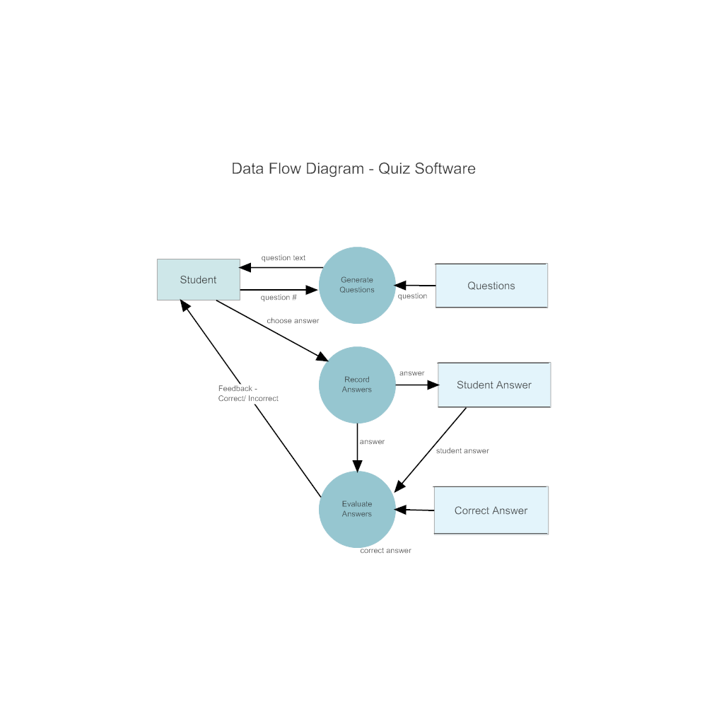

# Chapter 3:

## 3.1 Version Control: GitHub

**3.1.1 Choice of GitHub:**

Reasons for Selection: GitHub was chosen for its robust version control features, collaborative tools, and widespread adoption in the development community.

**3.1.2 Branching Strategy:**

Master Branch: Created a master branch dedicated to production-ready code, ensuring stability and reliability for end-users.

Develop Branch: Established a "develop" branch for ongoing testing and integration of new features before they were merged into the master branch.

Feature Branches: Employed feature branches to isolate work on specific features or enhancements, facilitating parallel development without affecting the main codebase.

**3.1.3 Issue Tracking:**

Creation of Issues: Utilized GitHub's issue-tracking system to document and manage tasks, enhancements, and bugs.

Two Main Issues:

Production Issue: Opened an issue for tracking production-related tasks and bug fixes.

New Feature Implementation: Created an issue for each new feature, outlining the scope and tasks required for implementation.

**3.1.4 Pull Requests:**

Feature Integration: Created pull requests to propose changes from feature branches into the "develop" branch, allowing for code review and discussion before merging.

Branch Merging: Ensured proper testing and approval before merging feature branches into the "develop" branch for further testing.

Release Merging: Followed a similar process for merging changes from the "develop" branch into the master branch for production releases.

**3.1.5 Collaborative Workflow:**

Team Collaboration: GitHub's collaborative features allow team members to work simultaneously on different features, ensuring efficient development.

Code Review: Leveraged the pull request and code review features to maintain code quality and consistency across the codebase.

**3.1.6 Continuous Integration:**

Integration with CI/CD Tools: Integrated GitHub with continuous integration/continuous deployment (CI/CD) tools to automate testing and deployment processes.

Automated Testing: Implemented automated testing in CI/CD pipelines to ensure that code changes did not introduce regressions or issues.

**3.1.7 Documentation and Comments:**

Commit Messages: Maintained clear and descriptive commit messages to provide a comprehensive history of code changes.

Documentation Updates: Ensured that documentation, including README files and inline comments, was consistently updated to reflect changes made in the codebase.

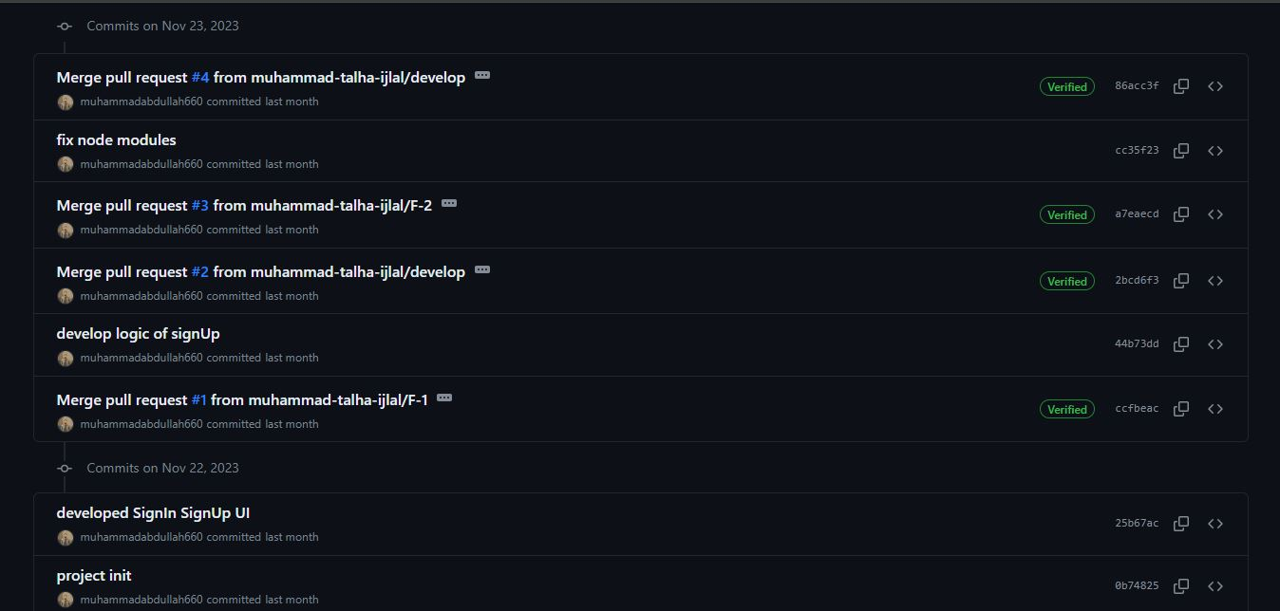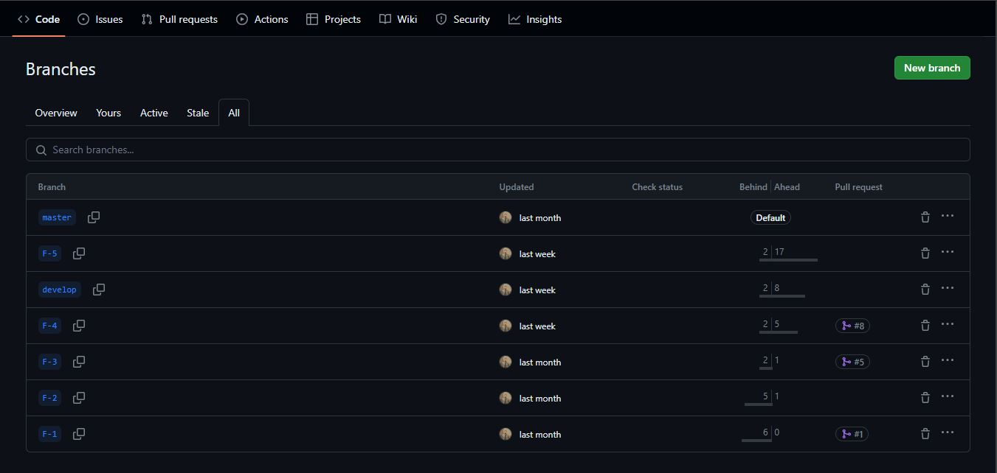

## 3.2 Communication Tool: Slack

**3.2.1. Selection of Slack:**

Chosen for its user-friendly interface, real-time messaging, and effective channel organization.

**3.2.2. Project-Specific Channel:**

Utilized a dedicated "QuizWiz" channel for centralized project discussions and decisions.

**3.2.3. Threaded Discussions:**

Implemented threaded discussions for organized and focused communication.

**3.2.4. Real-Time Collaboration:**

Enabled instant messaging, fostering quick decision-making and dynamic collaboration.

**3.2.5. Multimedia Sharing and Integration:**

Facilitated file sharing, integrated with project management tools (Clickup), and allowed customized notifications for seamless communication.

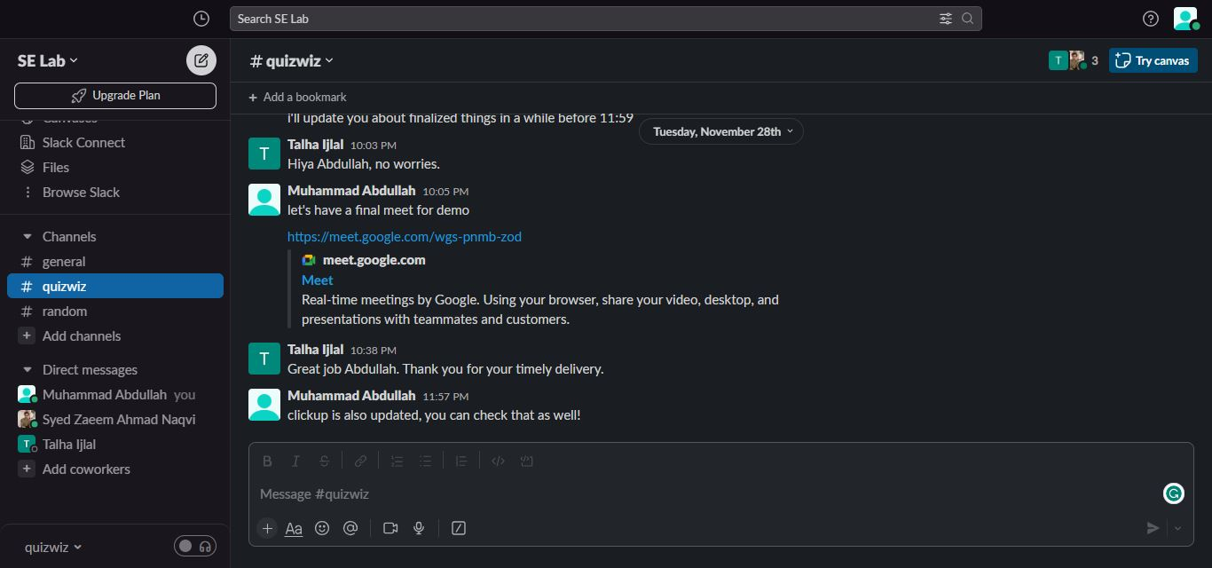

## 3.3 Project Management Tool: ClickUp

**3.3.1. ClickUp Selection:**

Decision Factors: Chose ClickUp for its versatility, intuitive interface, and comprehensive features suitable for development and collaborative tasks.

**3.3.2. Task Organization:**

Space and Folders: Organized tasks using ClickUp's Spaces and Folders for a well-structured project hierarchy.

Lists and Tasks: Implemented Lists and Tasks under relevant Folders, facilitating a hierarchical and navigable task structure.

**3.3.3. Agile Methodology Implementation:**

Sprints and Epics: Applied Agile methodology by breaking tasks into Sprints and grouping related tasks under Epics for iterative development.

Time Tracking: Utilized ClickUp's time-tracking features for progress monitoring and efficient resource allocation.

**3.3.4. Collaboration and Communication:**

Comments and Mentions: Leveraged Comments for task-specific discussions and @Mentions for team notifications, streamlining communication.

**3.3.5. Gantt Charts and Timelines:**

Visual Planning: Utilized Gantt charts and Timelines for visual project planning, identifying dependencies, and allocating resources effectively.

Nine Major Tasks: Created nine major tasks on the ClickUp board, providing a focused and actionable roadmap for project execution.

## 3.4 Best Practices

**3.4.1. Comments are Added:**

Practice: Comprehensive and clear comments are added throughout the codebase to explain complex logic, highlight important details, and provide context for easier understanding and maintenance.

**3.4.2. Proper Formatting:**

Practice: Consistent and standardized code formatting is maintained, following a set style guide. This ensures readability, and uniformity, and facilitates collaboration among developers.

**3.4.3. Naming Conventions Followed:**

Practice: Adherence to consistent naming conventions for variables, functions, classes, and other code elements. Clear and meaningful names enhance code readability and contribute to a more maintainable codebase.

**3.4.4. Proper Folder Structure:**

Practice: Establishment of a well-organized folder structure that logically categorizes different aspects of the project. This facilitates easy navigation, reduces redundancy, and promotes a systematic approach to code management.

**3.4.5. Components Reused:**

Practice: Identification and encapsulation of reusable components or modules. Reusing code not only enhances efficiency but also reduces redundancy and minimizes the likelihood of errors across the codebase.

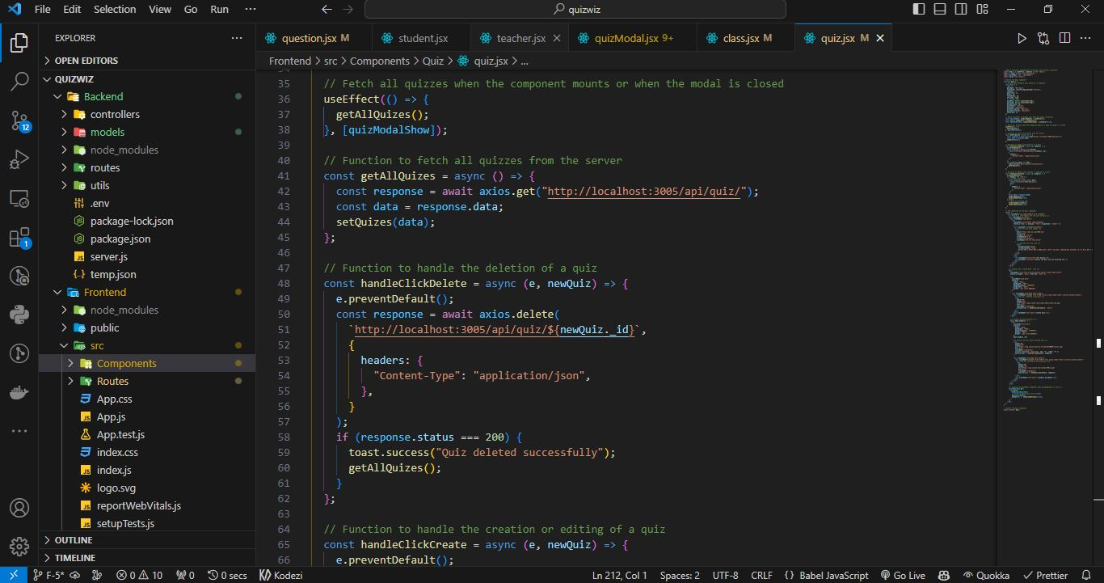

# Chapter 4:

## 4.1 SignUp

**Code:**

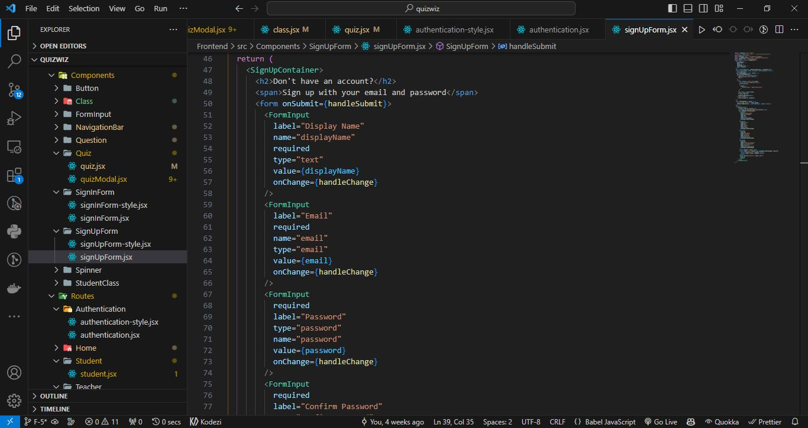

**Working Software:**

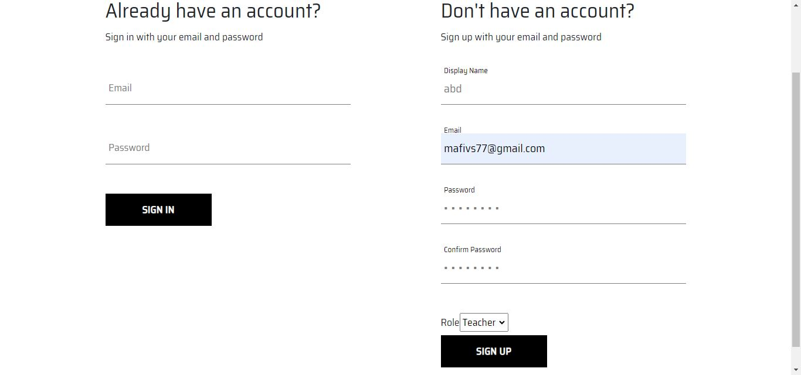

## 4.2 SignIn

**Code:**

**Working Sofware:**

## 4.3 Add Question/MCQ

**Code:**

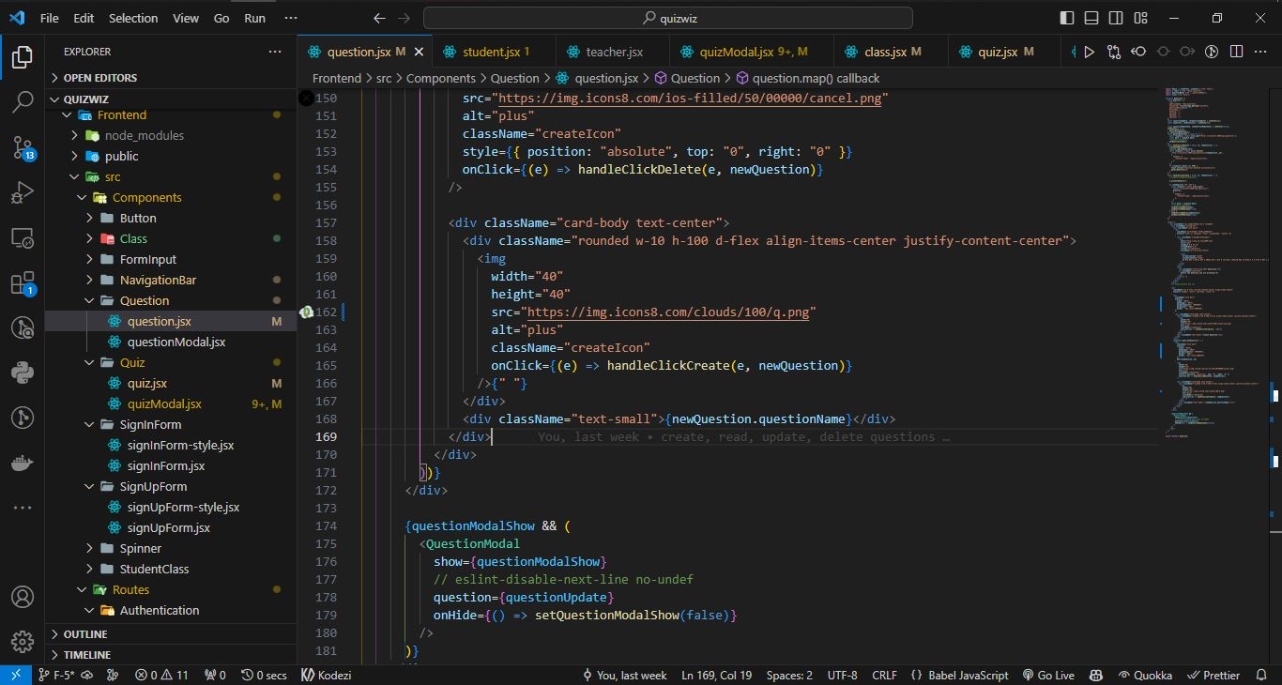

**Working Software:**

## 4.4 Update Quiz

**Code:**

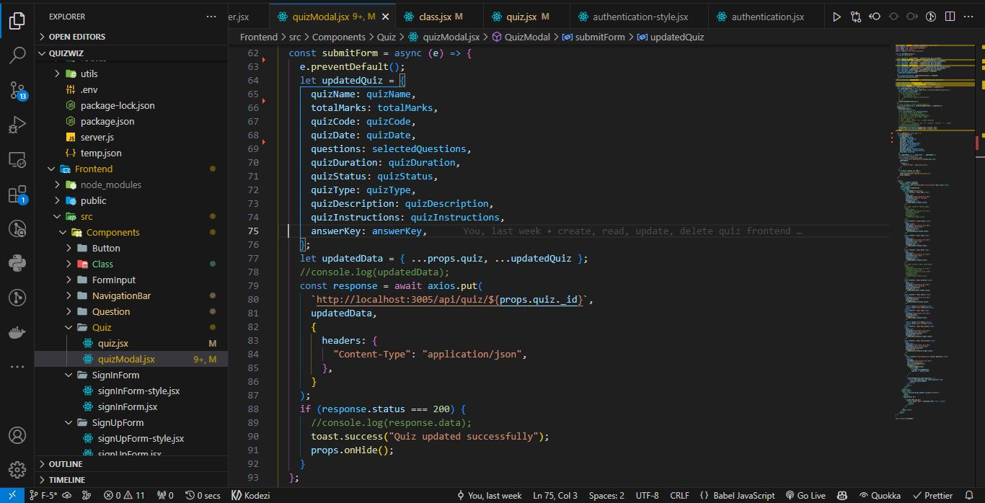

**Working Software:**

## 4.5 Give Quiz

**Code:**

**Working Software:**

